Document for Draft Technical Specification of
“Transformer repairing tender with implementation of IS 18284:2023 for repair of Distribution Transformers-code of practice”
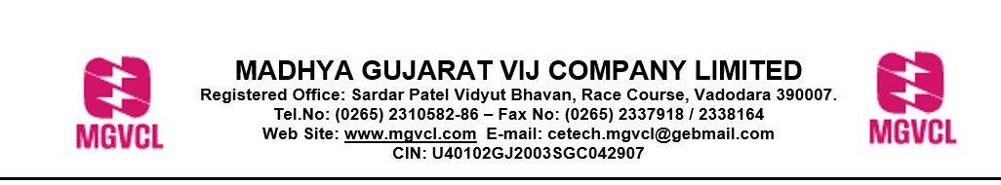

Public Notice
GUVNL invites views/comments/suggestions from public/suppliers/repairers on the draft technical specification of transformer repairing tender with implementation of IS 18284:2023 for repair of Distribution Transformers-code of practice.
The views/comments/suggestions may be submitted up to 26.09.25 by an email on any of the following email addresses

Email Addresses:
ceom@dgvcl.com;
seom2@dgvcl.com;
deom6@dgvcl.com

Comment Format
Name:
Address:
Contact No:
Email ID:

Sr.No. | Existing Clause | Comment | Justification for comment

